МЕТОДЫ

GAM

~~To illustrate finer-scale temporal patterns over 24 hours, we considered trends in mean index value from each hour. To do this, Generalized Additive Models (GAM) with a beta distribution were used. GAMs were chosen because preliminary analysis of the time-series indicated non-linear relationships (Hastie & Tibshirani, 1990; Wood, 2017). According AIC’s results, the model with the effect of time of day and seasons as separate smoothers was chosen.~~

The average value of the index for each hour of observation was divided by its maximum value recorded over the entire observation period. The obtained value for all indices was distributed in the interval from 0 to 1 and reflected the fraction of the recorded signal from its maximum value. This value was used as the dependent variable for construction of Generalized Additive Models (GAM) based on the beta distribution. GAMs were chosen because preliminary analysis of the time-series indicated non-linear relationships (Hastie & Tibshirani, 1990; Wood, 2017).

The predictors in these models were day time (a continuous variable distributed between 0 and 24), month (continuous variable distributed in the interval from 1 to 12) and index type (discrete predictor with five levels). In the case of continuous predictors, the smoothers were fitted using cyclic cubic regression splines as basis (Pedersen et al 2019). Four candidate models were considered: (1) model with separate smoothers fitted for each index for both day time and months; (2) separate smoothers for day time was fitted for each index, but a common smoother for all indices for months; (3) similarly, a common smoother for day time and separate smoothers for each index for months; (4) a common smoother for all indices for both time of day and months. The constructed models were compared using the Akaike information criterion (AIC). The model of the first type was recognized as optimal.

This statistical analysis was conducted in R programming language (R core Team, 2023) using the ´gam()´ function from package “mgcv_1.9-0” (Wood, 2017). Parameters were estimated using restricted maximum likelihood (REML). Model fit was evaluated through visual inspection of residual plots and diagnostic information produced using the “gam.check()” function from “mgcv_1.9-0” package (Wood, 2017). The packages “ggplot2_3.4.2” (Wickham, 2016) and “gratia_0.8.1” (Simpson, 2018) were used for data visualization.

RDA

To assess how seasons and time of day shape patterns of community composition we represented the data as a matrix with percentages of intervals with sounds from seven BD categories (я бы подробнее описал как эта матрица была сконструирована. Или про это раньше в M&M?). This matrix was used as a dependent array in the redundancy analysis (RDA; Legendre and Legendre 2012), in which seasons (Spring, Summer, Autumn, Winter) and time of day (Day, Night) were used as discrete predictors. The same analysis was conducted for five insect’s clusters (Здесь тоже надо описать, как формировалась зависимая матрица). Significance evaluation of the multidimensional model as a whole, and significance of individual ordination axes was accomplished by permutation method (Legendre & Legendre, 2012) with 9999 permutations. For this multidimensional analysis, functions of package “vegan_2.6-4” were used (Oksanen et al., 2018).

~~For visualization RDA we used the packages “ggvegan_0.1.999” () and “cowplot_1.1.1” ().~~

Нарисуем финальную картинку в ggplot2. Симпсон пока не удосужился выложить ggvegan на CRAN.

РЕЗУЛЬТАТЫ

**The temporal patterns in acoustic indices**

The GAMs showed that all indices were significantly affected by both the time of day and month (Table 1…). Different indices, however, had different diurnal dynamics (Figure 1…). The only exceptions were BI_6.5 and ADI, which showed similarly trends. Both indices showed high values at night. They decreased significantly before dawn (approximately 4 a.m.) and then increased rapidly until 6 a.m. A relatively slow decrease to the minimum values was observed from 11 a.m. to 3–4 p.m. At dusk, the indices showed a rapid increase until 7 p.m. and then a slight decrease before entering the plateau at night (Figure 1…). In summary, the values of both indices were higher at night than during the day, and there were two peaks at 6 a.m. and 7 p.m. (Figure 1…).

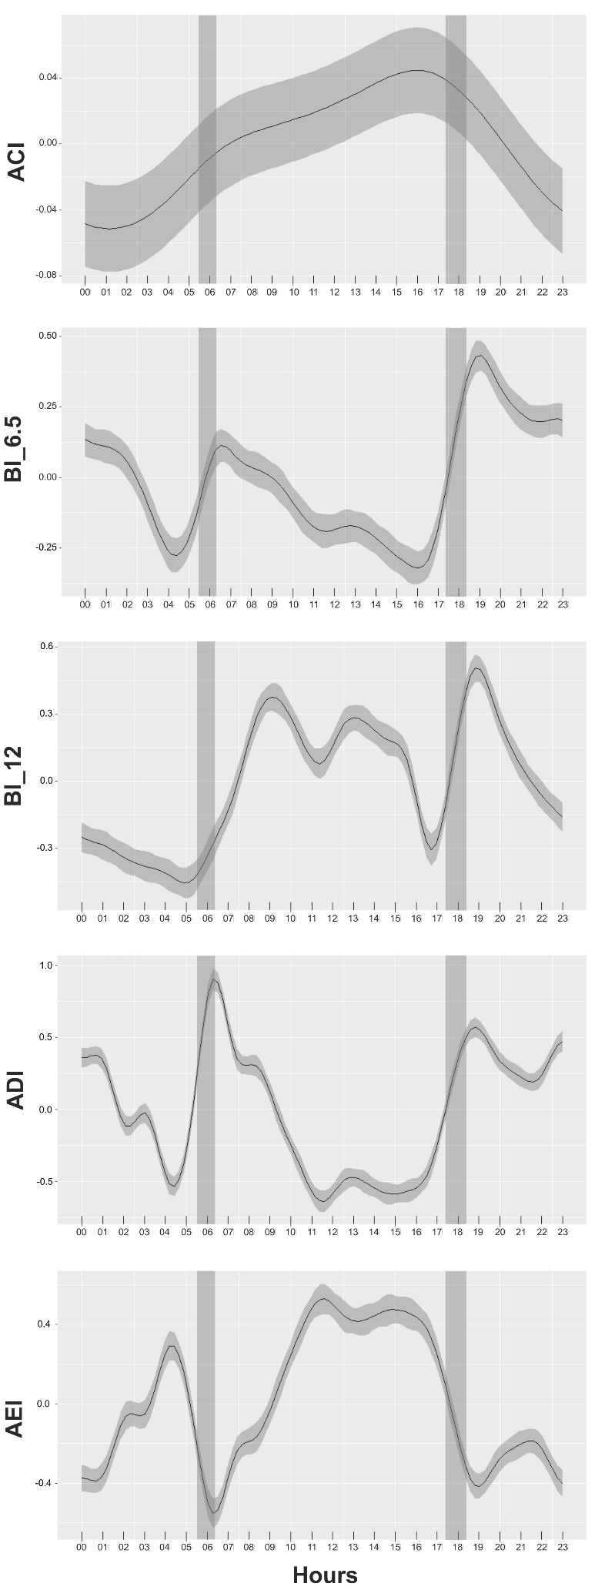

**Figure 1….** Diel patterns in mean acoustic indices from GAM output. Gray areas show the annual shift in the sunrise and sunset time at our study site.

Напомните! Убрать серый фон Может еще раскрасить день и ночь по градиенту синей заливки. Нет ли данных по уровню освещенности в течение суток той геолокации, где проводились работы? Можно сделать красиво.

**Table 1….** Results of generalized additive model (GAM) assessing the temporal patterns of acoustic indices

|  |  |  |
| --- | --- | --- |
|  |  |  |
| n | 62 650  0.61  65.2% | |
| R2 |
| Deviance explained |
| Significance of smooth terms | EDF | *p*-value |
| s (time of day) × ACI | 3.285 | **< 0.001** |
| s (time of day) × BI_6.5 | 16.262 | **< 0.001** |
| s (time of day) × BI_12 | 18.570 | **< 0.001** |
| s (time of day) × ADI | 20.872 | **< 0.001** |
| s (time of day) × AEI | 19.258 | **< 0.001** |
| s (month) × ACI | 1.782 | **0.039** |
| s (month) × BI_6.5 | 9.817 | **< 0.001** |
| s (month) × BI_12 | 9.888 | **< 0.001** |
| s (month) × ADI | 9.966 | **< 0.001** |
| s (month) × AEI | 9.927 | **< 0.001** |

Мне не очень нравятся значки × может лучше “:” или “by” или “for”.

The trend of BI_12 was different from the trend of the same index for the lower frequency spectrum (Figure 1…). At night, BI_12 had low values until 5 a.m. and then increased until 9-10 a.m. After that, there was a slow decrease until 11 a.m., and a more pronounced decrease between 3 p.m. and 5 p.m. was observed. Around dusk, a rapid increase with a pronounced peak at 7 p.m. was observed.

AEI showed a pattern opposite to ADI (Figure 1…).

ACI values were lowest at night until 4 a.m. (Figure 1…). This index then gradually increased until 16 p.m., followed by maximal values until 17 p.m. After that, the values rapidly decreased to minimum until nigh. Thus, ACI had two peaks at 6 a.m. and 4 p.m. and a less pronounced peak at 7 p.m.

Важно! Здесь нужно описание динамики еще и по месяцам.

**Results of the redundancy analysis for sounds of the seven BD categories.**

RDA confirmed the existence of seasonal and diel differences in compositions of study community. This model was statistically significant as well as the two constrained axes, RDA1 and RDA2, which described 16.7% of total variability (Table 2…). The RDA1, associated with time of day (Fig. 2, 3), described 9.0% of total variability. The RDA2, associated with seasons (Fig. 2, 3), described 7.7% of total variability.

**Table 2….** Permutational assessment of RDA results for the BD categories

|  |  |  |  |  |
| --- | --- | --- | --- | --- |
| Source of variation | Degrees  of freedom | Variance | *F* | Permutation  *p*-level |
| **Whole model** |  |  |  |  |
| Model | 4 | 83.64 | 5.19 | 0.0001 |
| Residuals | 95 | 382.98 |  |  |
| **Constrained axes** |  |  |  |  |
| RDA1 (9.0%) | 1 | 42.14 | 10.45 | 0.0002 |
| RDA2 (7.7%) | 1 | 35.95 | 8.92 | 0.0009 |
| Residuals | 95 | 382.98 |  |  |
| **Predictors** |  |  |  |  |
| Time of day | 1 | 40.24 | 9.98 | 0.0001 |
| Seasons | 3 | 44.45 | 3.68 | 0.0001 |

All BD categories were distributed along the RDA1 axis according to time of day (Figure 2…). Birds (Bird) and frogs and reptiles (Anur) demonstrated the highest positive and the highest negative loadings on the RDA1 axis, which indicates that these two BD categories demonstrated the strongest diel changes. The association of other BD categories with RDA1 (i.e., diel variation) was somewhat weaker (Figure 2…). On the other hand, insects (Ins) and wind (Wind) demonstrated the highest positive and the highest negative loadings on the RDA2 axis, which indicates that these two BD categories demonstrated the strongest season changes (Figure 2…). The relationship of the BD categories with the RDA1and RDA2 scores showed more detailed in Figures 3… and 4….

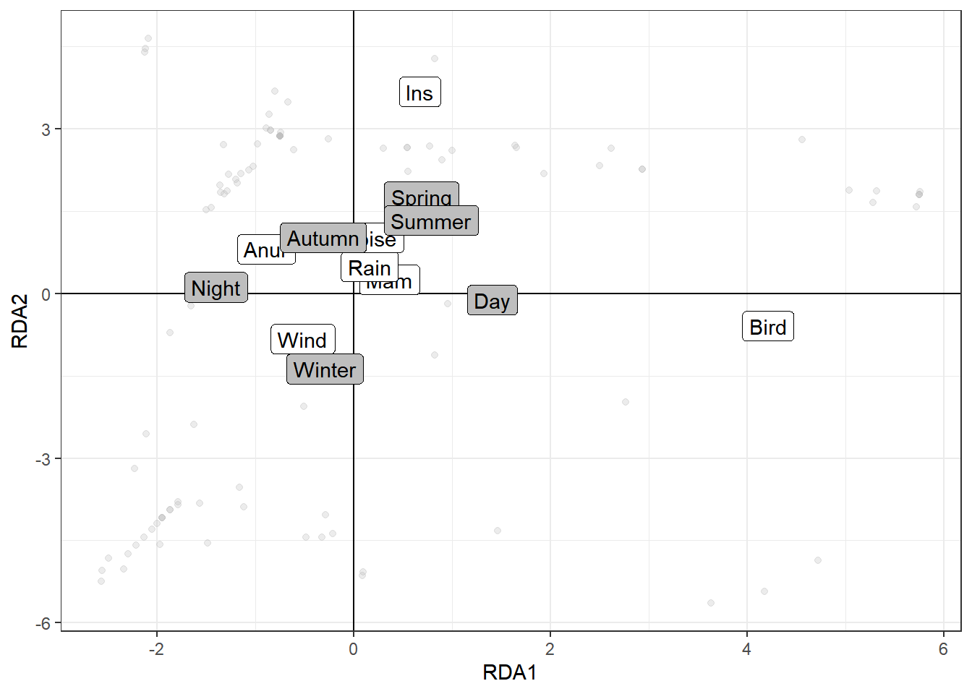

**Figure 2….** Ordination of seven BD categories (white squares) in the plane constrained RDA1 ~~(time of day)~~ and RDA2 ~~(seasons)~~ axes. Тут не надо писать трактовок осей. Это первичное представление модели.

Напомните! Надо отрегулировать прозрачность Табличек и к осям вывести долю объясненной дисперсии.

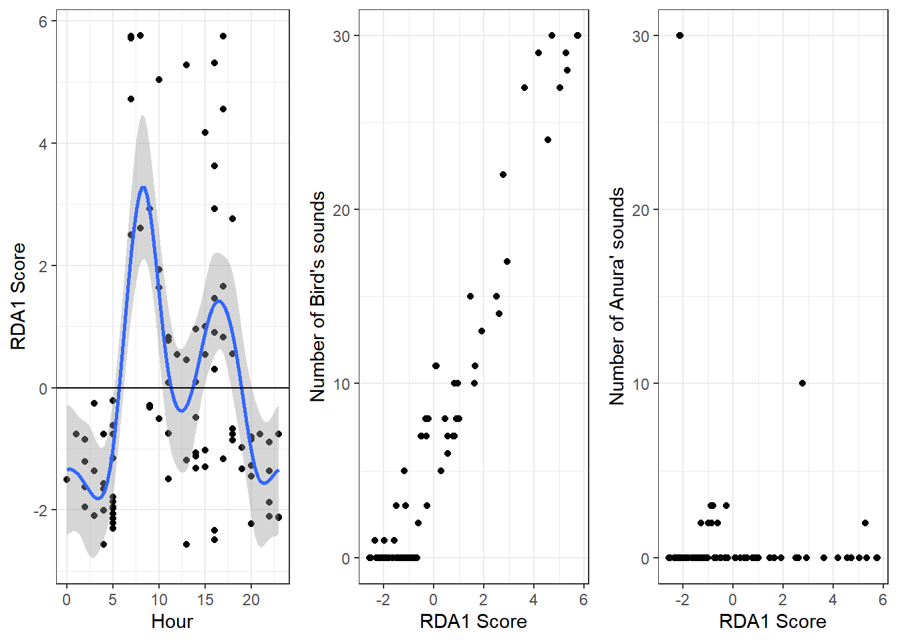

**Figure 3….** The distribution of the RDA1 scores along time of day (A) and loading of the numbers of bird’s (B) and frog’s and reptile’s (C) sounds on the RDA1 scores. Blue line represents loess smoother.

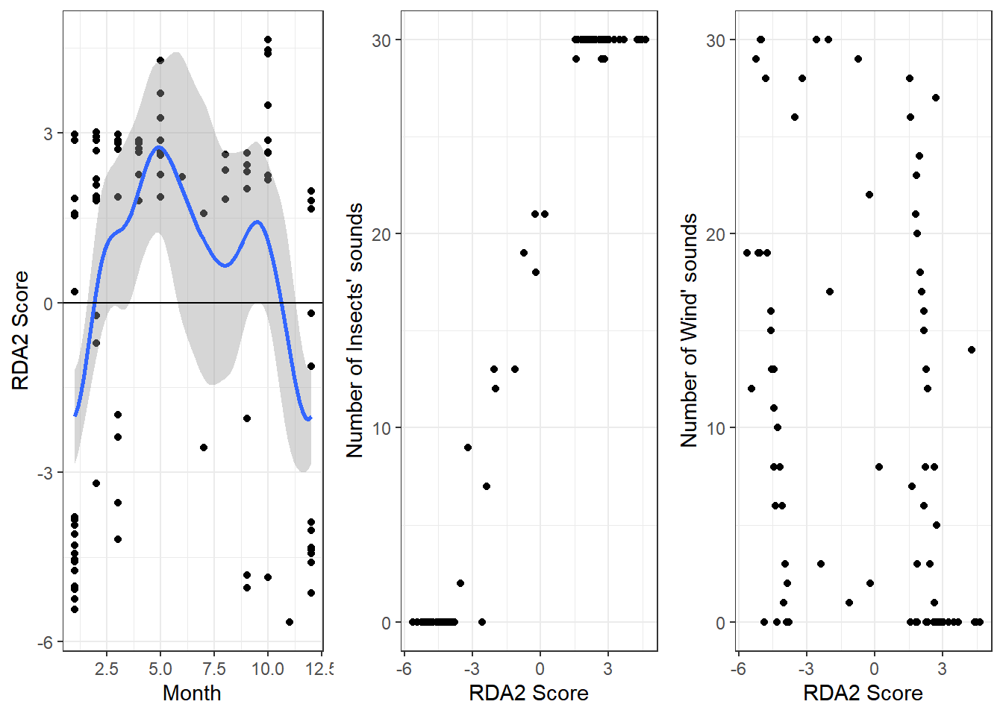

**Figure 4….** The distribution of the RDA2 scores along the seasons (A) and loading of the numbers of insect’s (B) and wind’s (C) sounds on the RDA2 scores. Blue line represents loess smoother.

Напомните! Надо поменять шкалу ОХ для Fig4, сделать месяцы целыми.

**Results of the redundancy analysis for sounds of the five insect’s clusters.**

Results of RDA showed seasonal and diel differences in the local insect community. The model was statistically significant (Table 3…). The only statistically significant constrained axis, RDA1, associated with both the time of day and the seasons, described 5.1% of total variability.

**Table 3….** Permutational assessment of RDA results for the insect’s clusters.

|  |  |  |  |  |
| --- | --- | --- | --- | --- |
| Source of variation | Degrees  of freedom | Variance | *F* | Permutation  *p*-level |
| **Whole model** |  |  |  |  |
| Model | 4 | 28.05 | 2.8 | 0.0012 |
| Residuals | 94 | 234.98 |  |  |
| **Constrained axis** |  |  |  |  |
| RDA1 (5.08%) | 1 | 13.35 | 5.34 | 0.0228 |
| Residuals | 94 | 234.98 |  |  |
| **Predictors** |  |  |  |  |
| Time of day | 1 | 7.21 | 2.89 | 0.0234 |
| Seasons | 3 | 19.02 | 2.54 | 0.0056 |

The insect clusters were distributed along the RDA1 axis according to the season and the time of day predictors (Figure 5…). Clusters 1 and 4 demonstrated the highest positive association with the time of day while Cluster 2 demonstrated the highest negative association with this predictor. Clusters 3 and 5 showed an intermediate position between daytime and nighttime. On the other hand, Cluster 4 showed association with Autumn, Cluster 3 – with Spring, Clusters 2 and 5 showed an intermediate position between Summer and Winter, and Cluster 4 - between Autumn and Spring (Figure 5…). Последнее предложение предлагаю писать с оговорками, так как вторая ось не имеет статистической занчимости.

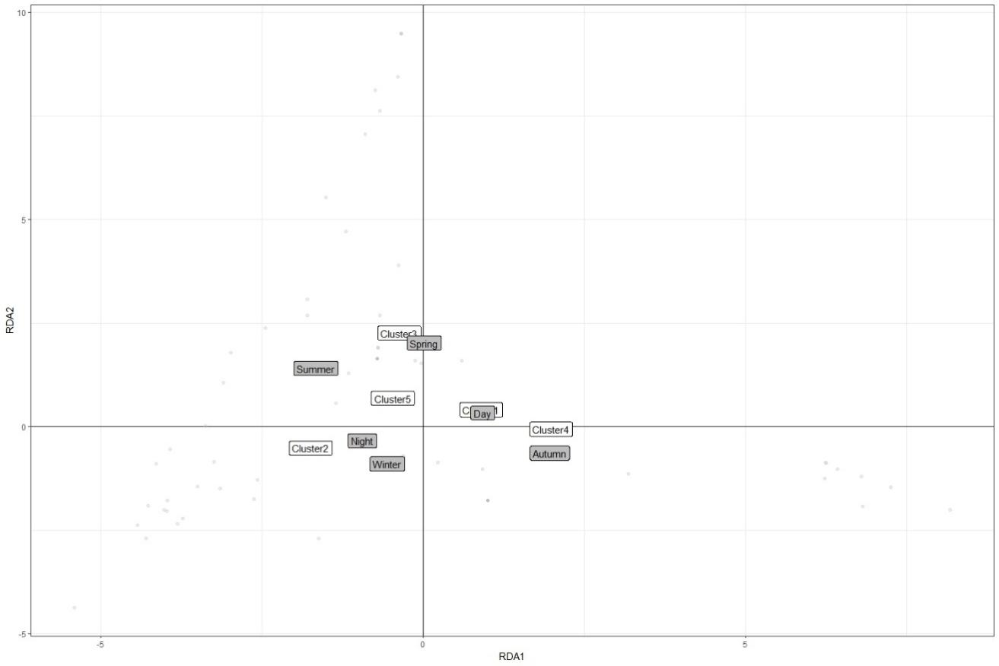

**Figure 5….** Ordination of the five insect clusters (white squares) in the plane constrained RDA1 (time of day and season) axis.

**Reference**

Hastie, T., Tibshirani, R. (1990). Generalized Additive Models. Chapman and Hall/CRC, London.

Legendre P, Legendre LF (2012) Numerical ecology, vol 24. Elsevier, Amsterdam

Oksanen, J., Blanchet, F.G., Friendly, M., Kindt, R., Legendre, P., McGlinn, D., Minchin, P.R., O’Hara, R.B., Simpson, G.L., Solymos, P., Stevens, M.H.H., Szoecs, E., Wagner, H. (2018). Vegan: community ecology package. R package version 2.4-6. https ://CRAN.R-proje ct.org/packa ge=vegan

Simpson GL. 2018. Gratia: graceful ggplot-based graphics and other useful functions for gams fitted using mgcv. Available at <https://CRAN.R-project.org/package=gratia>.

Wickham H. 2016. Ggplot2: Elegant graphics for data analysis. New York: Springer-Verlag.

Wood, S.N. (2017).Generalized additive models: An introduction with R*.* 2nd edition. Boca Raton, FL: Taylor and Francis.